Computer Hardware 
TERM | NAME – Student ID | COURSE CODE | WEIGHT
 | Greemesh Basnet - 130525223 | CSN105 | 8%
Lab Objectives
Upon completion of this lab, you will be able to perform the following:
- Identify the components of a computer
- Install and replace computer system components
- Access and configure the BIOS
Lab Materials
- Pre-Lab Video: Explanation
- PC Building Simulator: Education Edition
Lab Instructions
- Install PC Building Simulator: Education Edition
- Launch software and perform lab
- Enter your name and student ID above (Example: david – dtrinh)
- Answer questions and add screenshots into the corresponding textboxes
- Save the file on your computer for future reference
- Save the file again as a “.pdf” file
- Submit the PDF file for grading

Part 1: Configure Simulator Options
- Launch PC Building Simulator: Education Edition
- Select the gears icon to change the software options
- Select “Quality”: set the highest quality possible
- Select “Resolution”: set it to an appropriate size
- Uncheck “Fullscreen”
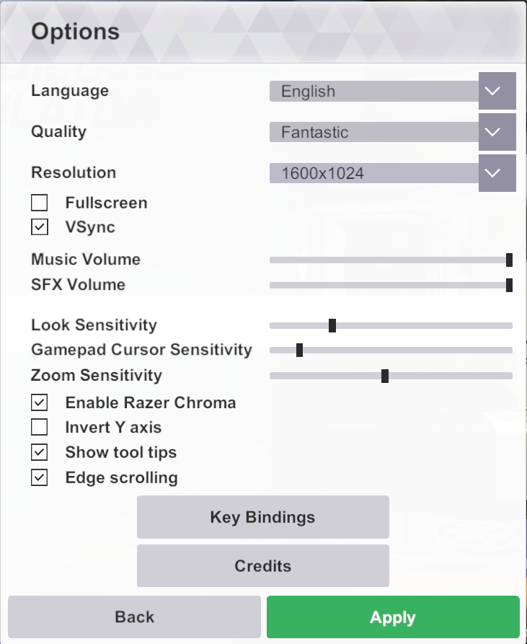
- Click “Apply” to save the settings

Part 2: How to Build a PC
- Launch “How to Build a PC”
- Navigate through the tutorial and familiarize yourself with how to install components
- Complete the tutorial

Your work is NOT saved in this mode. Exiting will erase all your work!
Part 3: Motherboard
- Launch “Free Build”. This mode will automatically save your work.
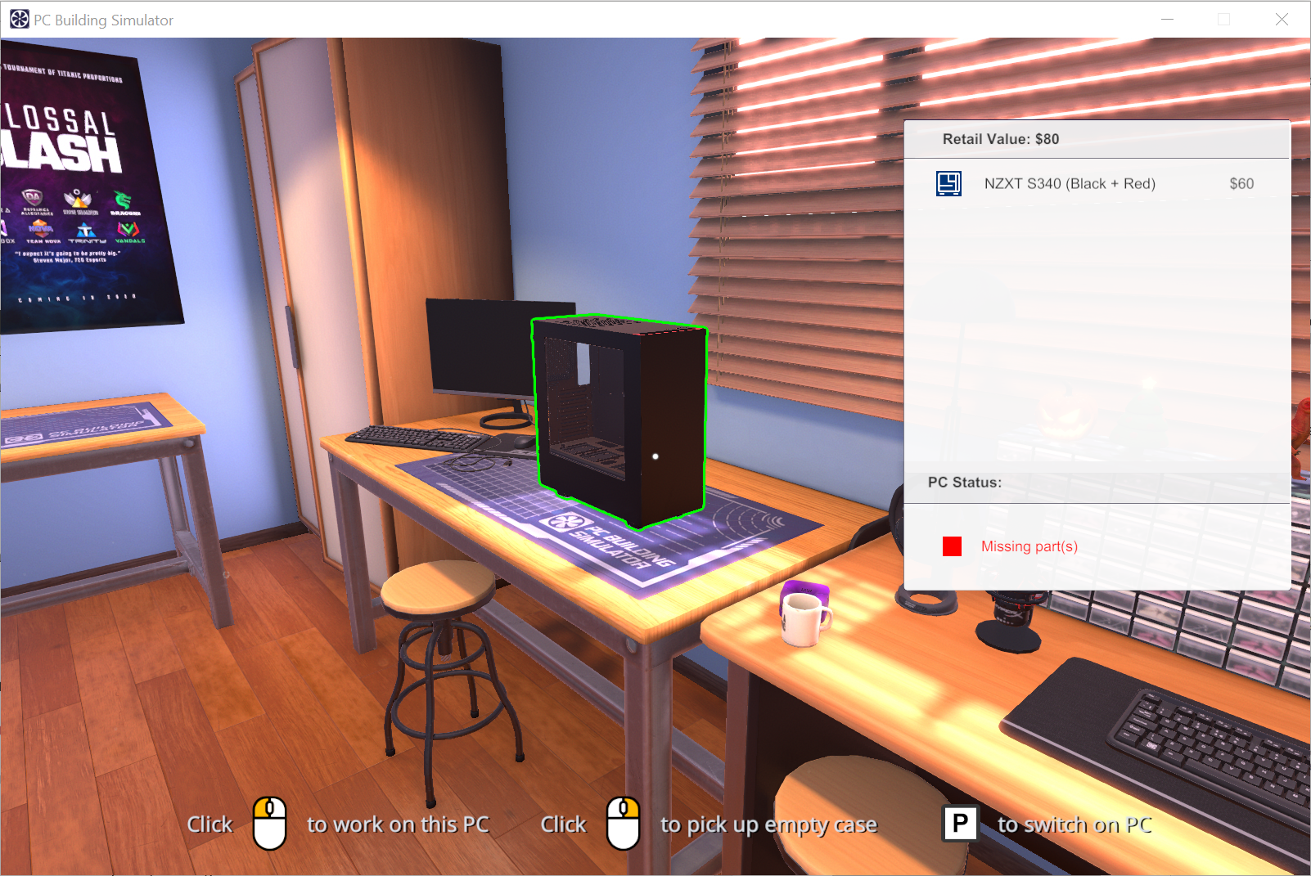
- Navigate to the PC sitting on the table to the left

- We will install a motherboard in the computer case
- Select the computer case on the table to work with it
- Remove the side panels before installing the motherboard
- Select the “INSTALL” button to view a list of available categories
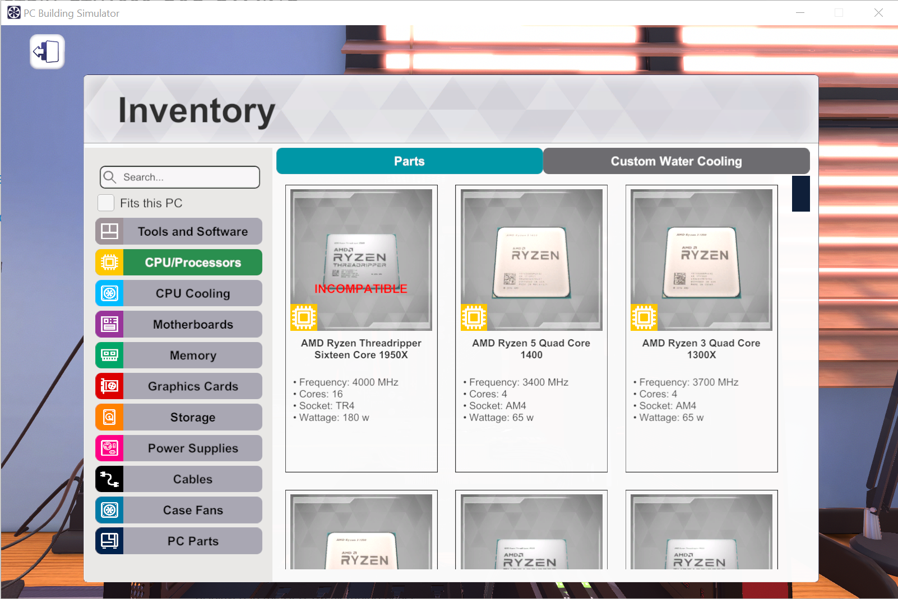
Why are some motherboards incompatible? [1 mark]
Some Motherboards are incompatible because they are designed for a specific brand and generation of CPU.
- Select the motherboard category and view the available models

- Install motherboard: “GIGABYTE X570 AORUS XTREME(rev 1.0)”
- Use the manufacturer’s website to answer the following questions:
What is the manufacturer’s website? [1 mark]
https://www.aorus.com/en-ca/motherboards/X570-AORUS-XTREME-rev-10/Key-Features

Which keyboard key is used to enter the BIOS setup? [1 mark]
In order to access BIOS setup, we need to enter DELETE KEY.

What does 5 short beeps indicate? [1 mark]
5 short beeps indicate there has been a processor error.

What is the version of the latest BIOS update? What does the update provide? [1 mark]
Rev.1.0 is the latest BIOS update version.

Part 4: Central Processing Unit
- We will install a CPU onto the motherboard
- Select the CPU/Processors category and view the available models
Why are some CPUs not supported? [1 mark]
Some CPUs are not supported because the processor is not idle for any length of time or either CPU isn’t compatible with the OS that is being used.

- Install CPU: “AMD Ryzen 9 Sixteen Core 3950X”
- Use the manufacturer’s website to answer the following questions:
What is the manufacturer’s website? [1 mark]
https://www.amd.com/en/products/cpu/amd-ryzen-9-3950x

Explain how to determine if this CPU supports multithreading. [1 mark]
Click or tap here to enter text.

What type of system memory is supported? [1 mark]
Click or tap here to enter text.


Remember to close the latch after placing the CPU in the socket.
- Install an appropriate CPU Cooling

Remember to add thermal paste under the “Tools and Software” category.
Part 5: Memory
- Using the motherboard’s manual, determine how 2 memory modules should be installed into the sockets.
- Select the memory category and view the available models
- Install memory: “G.SKILL Trident Z (Black) 8 GB 4400 MHz”

Remember to open the memory clips before installing the memory.
- Use the manufacturer’s website to answer the following questions:
What is the manufacturer’s website? [1 mark]
https://www.gskill.com/product/165/166/1536658028/F4-4400C18D-16GTZR

Memory can be sold in different kits. Which kit does this memory come in? [1 mark]
Click or tap here to enter text.

Part 6: Storage Devices
- Select the storage category and view the available models
- Install “Seagate BarraCuda 4TB 256MB Cache”
- Also, install “ADATA XPG SPECTRIX S40G RGB M.2 2TB”
- Use the manufacturer’s website and our discussions to answer the following questions:
Seagate BarraCuda 4TB 256MB Cache

What is the manufacturer’s website? [1 mark]
https://www.seagate.com/ca/en/products/hard-drives/barracuda-hard-drive/

What physical interface does this hard drive use? [1 mark]
This hard drive uses SATA III 6 gb/s physical interface.

What is the rotational speed (RPM) of this hard drive? [1 mark]
The rotational speed of this hard drive is 5400 rpm.

ADATA XPG SPECTRIX S40G RGB M.2 2TB

What is the manufacturer’s website? [1 mark]
https://www.xpg.com/us/xpg/610

What physical interface does this storage drive use? [1 mark]
This storage drive uses PCIe Gen3x4 Interface.

What is the rotational speed (RPM) of this storage drive? [1 mark]
The rotational speed of this storage drive is 3500/3000 MB per second.

Explain a reason for installing 2 internal drives. [1 mark]
The two reasons for installing two internal drives are:
1.In case of failure in Hardware or any kinds of error several copies can be made of important files.
2.Backup data and information faster and easily.

Part 7: Graphics Card
- Select the Graphics Cards category and view the available models
- Install “ASUS ROG Strix GeForce GTX 1080 OC Edition”

Remember to remove the back panels to make space for the ports. After installing the graphics card, make sure you install a PCI lock to hold the card in place.
- Use the manufacturer’s website and answer the following questions:
What is the manufacturer’s website? [1 mark]
https://rog.asus.com/graphics-cards/graphics-cards/rog-strix/rog-strix-gtx1080-o8g-gaming-model/

What output interfaces are available? [1 mark]
Click or tap here to enter text.

How many monitors can be connected? [1 mark]
Click or tap here to enter text.

What is the version of the latest driver for Windows 10x64? [1 mark]
Click or tap here to enter text.

Part 8: Power Supply
- Select Power Supplies category and view the available models
- Install an appropriate power supply for the PC

- Remember to remove the PSU mount before installing the power supply. Once the PSU is installed, remember to install this PSU mount back on the case.

The PC Status should change from “Incomplete case” to “No OS installed”. If not, review the components to ensure nothing is missing.
Part 9: BIOS
- Power on the PC using the button located on the top of the case
- Click on the monitor to view the system boot
- Note the keys that need to be pressed to enter the BIOS
- Enter the BIOS and navigate until you find “Boot Device”
- Ensure the M2: ADATA XPG SPECTRIX S40G RGB M.2 2TB” is selected
Screenshot 9.0: Boot Device [1 mark]

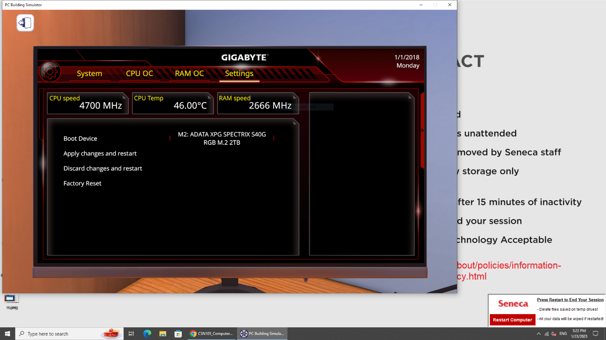

- Make sure the screenshot is large enough to show the required information.
- Select “Apply changes and restart”
- Power off the PC

Part 10: Software
- Select Tools and Software category and view the Parts tab
- Select the “USB Drive – USB Drive for OS and program installation”
- Install the USB in an appropriate port on the case
- Power on the PC using the button located on the top of the case
- Click on the monitor to view the system boot into an OS
- Using the “Add/Remove Programs” icon, install the following applications:
  - Part Ranking
  - System Info
  - Will it run?
- Launch “Part Ranking” and answer the following questions:
What is the highest ranked Graphics Card? [1 mark]
ZOTAC GAMING GeForce RTX 2080 Ti Amp Extreme

What is the lowest ranked processor? [1 mark]
Intel Celeron G3900 is the lowest ranked processor.

- Launch “System Info” and answer the following questions:
What is the “Case Temperature”? [1 mark]
The “Case Temperature” is 26.48 degree Celsius.

What is the “Transfer Speed” of the M.2 storage drive? [1 mark]
The “Transfer Speed” of the M.2 Storage drive is 3250 MB/s.

- Launch “Will it run?” and answer the following questions:
Does this PC meet the recommended spec for “DOTA 2”? [1 mark]
Yes this PC meets the recommended spec for Dota 2.

What specs need to be updated to meet the recommend 4k spec for “Doom”? [1 mark]
Click or tap here to enter text.

- Update the PC to meet the recommended 4k spec for Doom.
Screenshot 10.0: Doom 4K spec with new video card [1 mark]

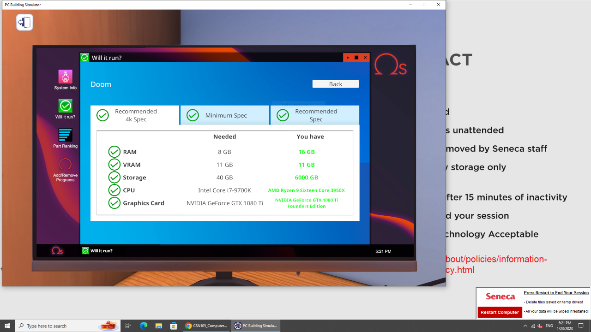

- Make sure the screenshot is large enough to show the required information.

